**Screenshots of all the calculations:**

Number and percentage of observations that are complete:

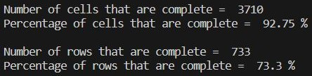

Percentage of data that has no errors (i.e., rows that don’t violate the mentioned rules):



Summary of the data before imputation:

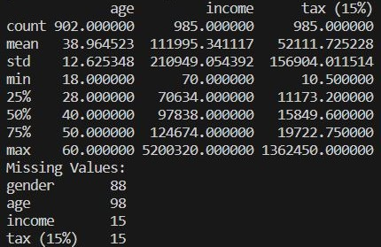

Summary of the data after imputation:

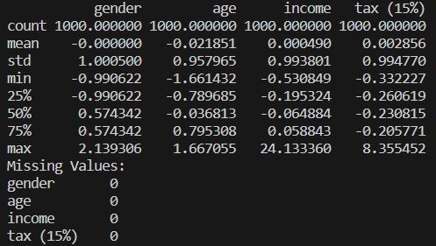

**Write a paragraph explaining the importance of cleaning a dataset before providing further analytics about the data.**

* The data cleaning process is estimated to consume around 25% of the entire data analysis process. This indicates the importance of data cleaning, which accounts for a quarter of the process. Real-world data collected via different mechanisms might be incomplete, faulty, noisy, or inconsistent due to instrument error, human error, computer error, transmission error, and many other factors. If raw data is used for analysis, it might not provide accurate information. Therefore, the reliability, accuracy, and integrity of the data must be maintained before any further analysis or modeling. Addressing these issues helps prevent biases and inaccuracies in the analysis results, leading to more accurate and reliable conclusions.